ACTIVITY 1

PURPOSE – the purpose of the site is to have a site where people can post trustworthy reviews of books that is parent approved by others who have read those books. Seeing as this site can be used by youth and adults making sure that at least one adult has read the books to make sure that it is adult approved for kids.

AUDIENCE- Adults and youth finding good and appropriate books to read

I think that some things that are needed to be on the website are genres of books and a little background on each book so that the parents and children know what is the expected story of the book.

ACTIVITY 2

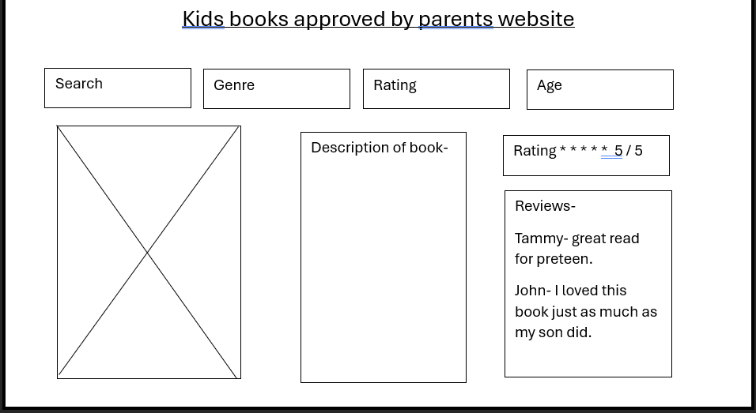

ACTIVITY 3

Reviews-

Tammy- great read for preteen.

John- I loved this book just as much as my son did.

Rating \* \* \* \* \* 5 / 5

Search

Genre

Rating

Age

Description of book-

Kids books approved by parents website